[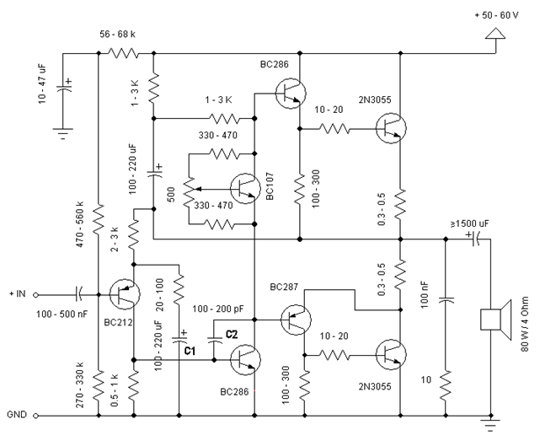](https://www.electronics-lab.com/wp-content/uploads/2015/03/2N3055_Power_Amplifier.gif)

Simple and low cost. The optimal supply voltage is around 50V, but this amp work from 30 to 60V. The maximal input voltage is around 0.8 – 1V. As you can see, in this design the components have a big tolerance, so you can build it almost of the components, which you find at home. The and transistors can be any NPN type power transistor, but do not use Darlington types… The output power is around 60W.

**Comments**

* capacitor C1 regulates the low frequencies (bass), as the capacitance grows, the low frequencies are getting louder.
* capacitor C2 regulates the higher frequencies (treble), as the capacitance grows, the higher frequencies are getting quieter.
* this is a class B amplifier, this means, that a current must flow through the end transistors, even if there is no signal on the input. This current can be regulated with the 500Ω trimmer resistor. As this current increases, the sound of the amplifier gets better, but the end transistors are more heating. But if this current decreases, the transistors are not heating so much, but the sound gets worse…

Hi can anyone tell me what wattage resistors to use please? Many thanks.

where power needs to flow (like collectors, emitters.) – otherwise – use 1/2 Watt resistors